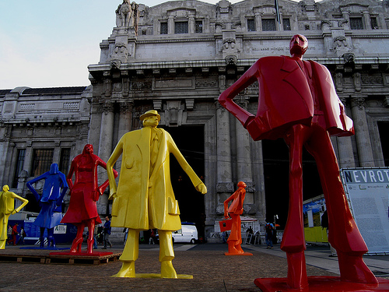

MASTERCLASS
Creative and attractive cities : the new urban competition

Prof. Silvia Mugnano,
Department of Sociology and Social Research
University of Milan Bicocca, Italy

21st March 2016 at 11.00 a.m.

At Department of Sociology
Kyiv Polytechnic Institute, Kiev , Ukraine

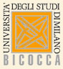

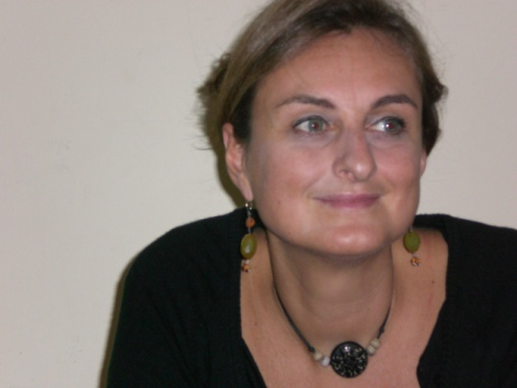 | Prof. Silvia Mugnano  Assistant Professor in Urban Sociology.  She has a Master in Social Research at University of Essex, UK and a Phd Un Policies Studies at Bristol University, UK. She has been Visiting Researcher at University of Barcelona, Spain.  She has been Research: her research fields are:  - Housing studies,  - Urban transformation,  - Neighborhood studies  - Creative industry. and creative cities  - Urban Tourism  - Natural disaster and Tourism  She has participated at several national nd international researches and she has been coordinated the Italian research unit of EU project  - NEIGHBOURHOOD TRAJECTORIES  - RESTATE (Restructuring Large Housing Estates in European Cities)  - ACRE (Accommodating Creative Knowledge – Competitiveness of European Metropolitan Regions within the Enlarged Union).  She has strongly involved in several Decentralised Cooperation Programme in Libanon and Central America.  She is member of the board of the International PhD programme URBEUR, Università di Milano Bicocca and she is at the moment supervising three PhD students.  She is the Erasmus coordinator for the BA program in Tourism and Local Community  She speaks Italian , English and Spanish

